Assignment No. 2

High-Level Use Cases
University Timetable Optimization and Management System
──────────────────────────────────────────────────────────────
Course | Software Engineering
Document Type | Formal assignment
Project | University Timetable Optimization and Management System
Purpose | High-level use case modelling

Prepared for academic submission. The content is project-specific and framed for a university timetable optimization website.

1. Introduction
This document presents the high-level use cases for the University Timetable Optimization and Management System. The aim is to define major user goals and system responsibilities without expanding into detailed event flows. Only system-wide, high-level interactions are included so that the model remains clean and academically consistent.
A deliberate modelling decision has been made to keep the use cases at a consistent abstraction level. For example, holidays and blocked periods are treated as part of calendar maintenance rather than as a separate peer use case, and manual locking is treated as an internal behaviour of timetable adjustment rather than as an independent high-level goal.

2. System Boundary and Scope
- The system covers timetable administration, timetable publication, and controlled timetable repair.
- The first version assumes course and section scheduling rather than fully personalized student-by-student scheduling.
- Algorithm selection is outside the scope of this document; the focus here is interaction modelling.
- The boundary includes calendar control, data maintenance, constraint definition, schedule generation, review, change handling, and reporting.

3. Actors
Actor | Role Type | Main responsibility
Timetable Administrator | Primary | Maintains core data and calendar settings; defines rules; generates, repairs, and publishes timetables.
Department Coordinator | Supporting / supervisory | Helps validate academic data, reviews constraints, and can submit change requests.
Teacher | Primary end user | Views assigned timetable and may request timetable changes when needed.
Student | Primary end user | Views the timetable relevant to the assigned class, section, or student group.
Facility Manager | Supporting actor | Reviews room utilization and resource-related reports.

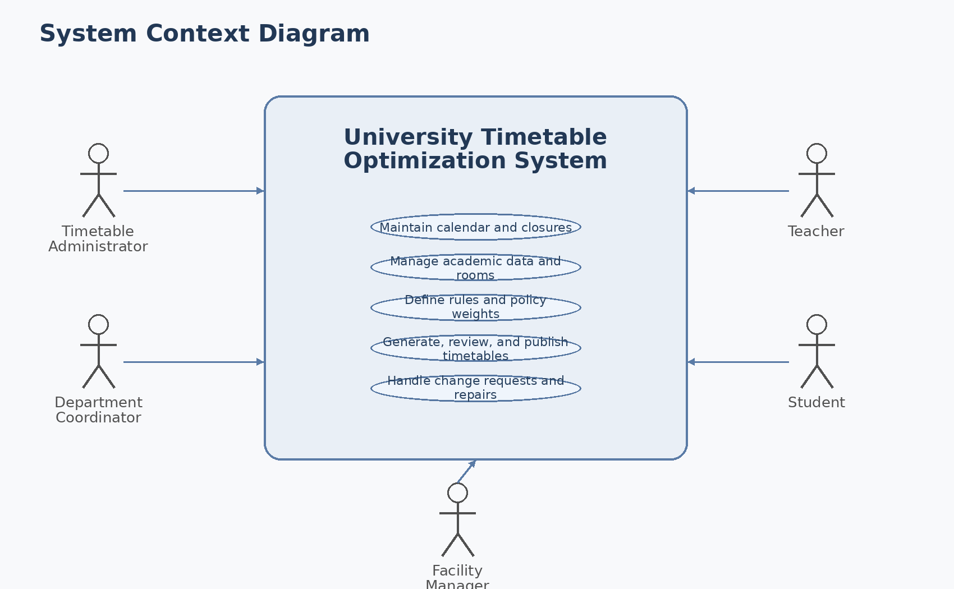
Figure 1. System context diagram showing external actors around the timetable system.

3.1 Diagram Description – System Context Diagram
The context diagram treats the timetable system as a single software boundary and shows which external actors interact with it. The Timetable Administrator is the main operational actor. The Department Coordinator contributes validation and change requests. Teachers and students primarily consume outputs, although teachers may also initiate change requests. The Facility Manager interacts with the reporting side of the system. This diagram is intentionally broad: it explains the external environment of the system before internal use cases are modelled.

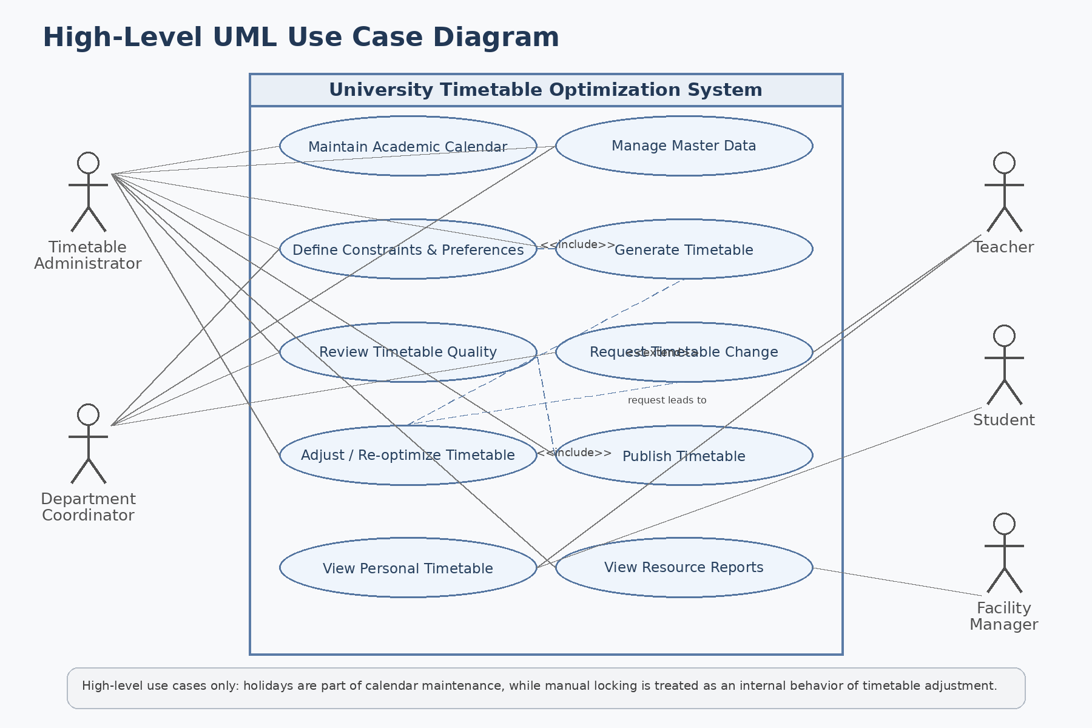
Figure 2. Revised high-level UML use case diagram.

3.2 Diagram Description – High-Level UML Use Case Diagram
The use case diagram shows ten high-level use cases that sit at a consistent abstraction level. Administrative functions are centered on the Timetable Administrator, while Teachers, Students, and the Facility Manager interact only with the goals that genuinely belong to them. The diagram also captures a small number of formal relationships: timetable generation includes the use of defined constraints and preferences; publication depends on successful review; and timetable adjustment extends the generation process when late changes must be accommodated.

4. Use Case Modelling Decisions
Modelling choice | Reason
Holidays and blocked periods | Merged into Maintain Academic Calendar because they are calendar-control responsibilities, not a separate peer-level user goal.
Teacher change handling | Split into two use cases: Request Timetable Change (teacher/coordinator goal) and Adjust / Re-optimize Timetable (administrator goal).
Manual locking | Treated as an internal behaviour inside timetable adjustment rather than an independent high-level use case.
Viewing functions | Kept separate because personal timetable viewing and resource-report viewing serve different actors and goals.

5. Relationship Notes
The following logical relationships exist among the use cases and are useful for reading the model correctly:
Source use case | Relation | Target use case | Meaning
Generate Timetable | <<include>> | Define Constraints and Preferences | A timetable cannot be generated without the active rule set.
Publish Timetable | <<include>> | Review Timetable Quality | Publication should happen only after the produced schedule is checked and accepted.
Adjust / Re-optimize Timetable | <<extend>> | Generate Timetable | Repair is a specialized case that occurs after a schedule already exists and new change pressure appears.
Request Timetable Change | triggers | Adjust / Re-optimize Timetable | The request creates the business reason for controlled repair.

6. High-Level Use Case Catalogue

UC01 – Maintain Academic Calendar
Actors | Timetable Administrator
Type | Primary
Essential | Define the working calendar and non-teaching periods used by the timetable.
Real | The administrator enters semester dates, working days, holidays, blackout dates, and blocked periods so classes are not scheduled in invalid slots.
Description | The system stores and manages the calendar structure that governs valid timetable periods.

UC02 – Manage Master Data
Actors | Timetable Administrator, Department Coordinator
Type | Primary
Essential | Maintain the academic and resource facts required for scheduling.
Real | The administrator records departments, programs, courses, sections, teachers, rooms, capacities, room features, and timeslots.
Description | The system stores the fixed input data on which generation and review depend.

UC03 – Define Constraints and Preferences
Actors | Timetable Administrator, Department Coordinator
Type | Primary
Essential | Specify the hard rules and soft policy priorities used in scheduling.
Real | The administrator defines teacher availability, room restrictions, no-clash rules, morning preference, room proximity, early ending preference, and similar weighted policies.
Description | The system records the rule set and preference weights that shape timetable generation and later repair.

UC04 – Generate Timetable
Actors | Timetable Administrator
Type | Primary
Essential | Produce a feasible timetable from the available data and rules.
Real | The administrator asks the system to create a weekly timetable that assigns classes to valid rooms and timeslots without breaking hard constraints.
Description | The system generates an initial schedule and prepares it for inspection.

UC05 – Review Timetable Quality
Actors | Timetable Administrator, Department Coordinator
Type | Primary
Essential | Evaluate whether the generated timetable is acceptable.
Real | The system displays clash reports, timetable quality indicators, room usage, and weak areas so the administrator can decide whether revision is required.
Description | The system presents review information that supports acceptance or further adjustment.

UC06 – Request Timetable Change
Actors | Teacher, Department Coordinator
Type | Primary
Essential | Submit a justified request for timetable modification.
Real | A teacher requests a timetable change because of leave, a recurring meeting, or a newly discovered conflict; a coordinator may also raise an academic clash.
Description | The system records the reason, scope, and priority of a requested timetable change.

UC07 – Adjust / Re-optimize Timetable
Actors | Timetable Administrator
Type | Primary
Essential | Repair the timetable while minimizing unnecessary disruption.
Real | After reviewing a change request, the administrator modifies or re-optimizes the timetable so that the affected classes are adjusted while stable assignments remain undisturbed as far as possible.
Description | The system supports controlled timetable repair, including internal locking of approved assignments where needed.

UC08 – Publish Timetable
Actors | Timetable Administrator
Type | Primary
Essential | Release the approved timetable for official use.
Real | Once the schedule has been reviewed and accepted, the administrator publishes it so that end users can access the final version.
Description | The system marks the timetable as official and makes it available to intended users.

UC09 – View Personal Timetable
Actors | Teacher, Student
Type | Primary
Essential | Access the timetable relevant to the current user.
Real | Teachers view their assigned classes and rooms, while students view the timetable for their section, semester, or student group.
Description | The system filters and displays the published timetable according to the identity of the logged-in user.

UC10 – View Resource Reports
Actors | Timetable Administrator, Facility Manager
Type | Primary
Essential | Review room and resource usage produced by the timetable.
Real | The facility manager checks room utilization, peak-load periods, and related reports to understand operational impact.
Description | The system presents administrative reports focused on resource usage rather than personal class schedules.

7. Use Case Summary Matrix
Use Case | Admin | Coordinator | Teacher | Student | Facility
Maintain Academic Calendar | ✓
Manage Master Data | ✓ | ✓
Define Constraints and Preferences | ✓ | ✓
Generate Timetable | ✓
Review Timetable Quality | ✓ | ✓
Request Timetable Change |  | ✓ | ✓
Adjust / Re-optimize Timetable | ✓
Publish Timetable | ✓
View Personal Timetable |  |  | ✓ | ✓
View Resource Reports | ✓ |  |  |  | ✓

8. Notes on Scope
- These use cases are intentionally high-level; detailed flows can be expanded later for generation, repair, publication, and reporting.
- The first version focuses on timetable creation and controlled repair, not on personalized student-by-student scheduling.
- Algorithm discussion is deferred to a later phase; this model describes system interaction and responsibility.

9. Conclusion
The revised use case set is stronger because each use case now represents a distinct high-level user goal, actor boundaries are clearer, and the summary matrix is fully consistent with the catalogue. The model remains practical for the timetable project while also being cleaner from a software-modelling perspective.

Selected References
- Craig Larman, Applying UML and Patterns.
- Ian Sommerville, Software Engineering.
- Grady Booch, James Rumbaugh, and Ivar Jacobson, The Unified Modeling Language User Guide.

